Topic: IMDB Database Design

Step 1: Creating Database imdb
Query: CREATE DATABASE imdb;
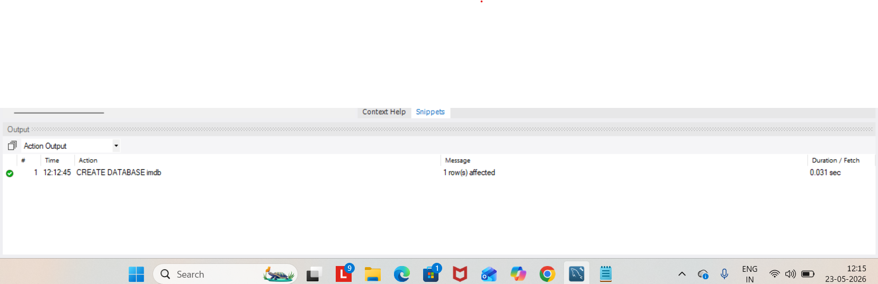

Step 2: Using Database
Query: USE imdb;

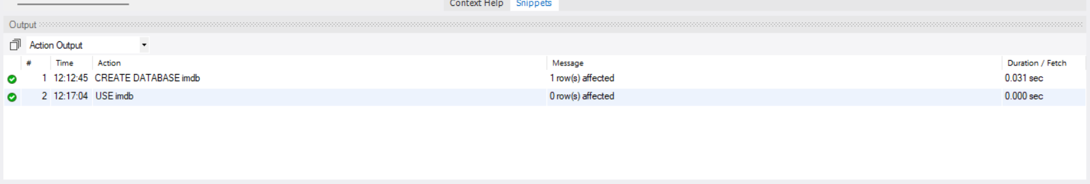

Step 3: Table for Movies is created
Query: CREATE TABLE movies (
movie_id INT PRIMARY KEY AUTO_INCREMENT,
title VARCHAR(100),
release_year YEAR,
language VARCHAR(50));
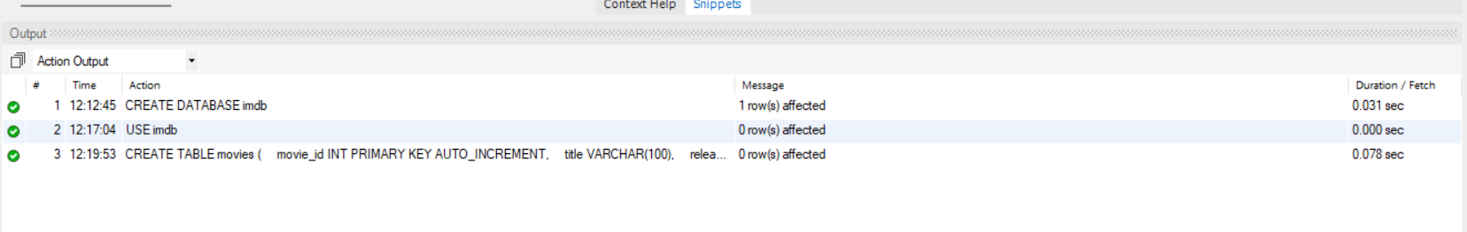

Step 4: Table for Media is created
Query: CREATE TABLE media (
media_id INT PRIMARY KEY AUTO_INCREMENT,
movie_id INT,
media_type VARCHAR(20), -- Image or Video
media_url VARCHAR(255),
FOREIGN KEY (movie_id)
REFERENCES movies(movie_id) );

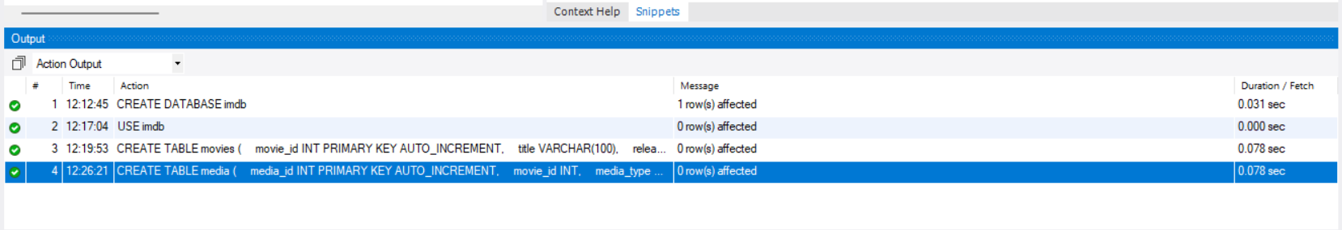

Step 5: Table for genres is created
Query: CREATE TABLE genres (
genre_id INT PRIMARY KEY AUTO_INCREMENT,
genre_name VARCHAR(50));

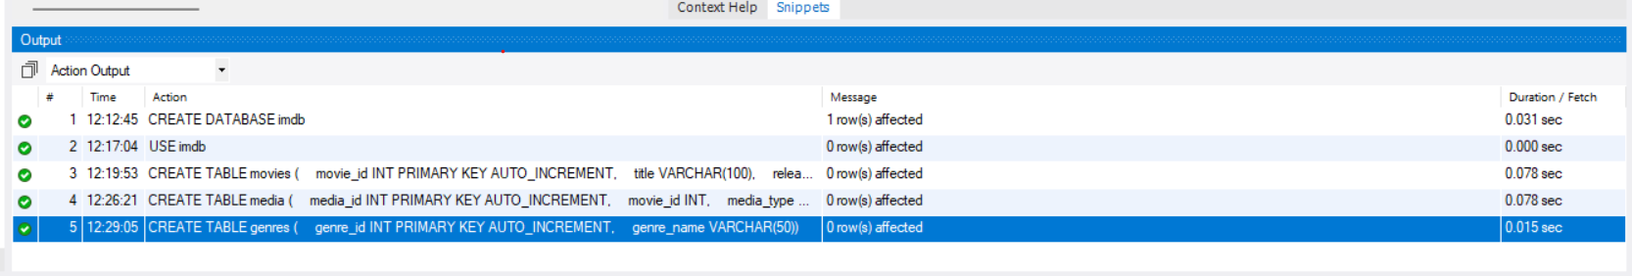

Step 6 : Movie_Genre Table (Many-to-Many Relationship)
Query : CREATE TABLE movie_genre (
movie_id INT,
genre_id INT,
PRIMARY KEY(movie_id, genre_id),
FOREIGN KEY(movie_id)
REFERENCES movies(movie_id),
FOREIGN KEY(genre_id)
REFERENCES genres(genre_id));
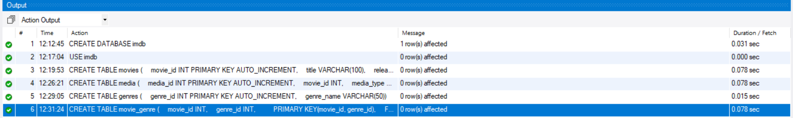

Step 7: Users Table
Query: CREATE TABLE users (
user_id INT PRIMARY KEY AUTO_INCREMENT,
username VARCHAR(100),
email VARCHAR(100));

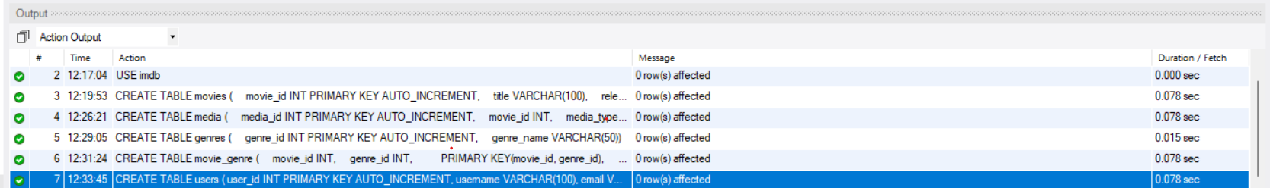

Step 8: Reviews Table
Query: CREATE TABLE reviews (
review_id INT PRIMARY KEY AUTO_INCREMENT,
movie_id INT,
user_id INT,
rating DECIMAL(2,1),
comment TEXT,
FOREIGN KEY(movie_id)
REFERENCES movies(movie_id),
FOREIGN KEY(user_id)
REFERENCES users(user_id));

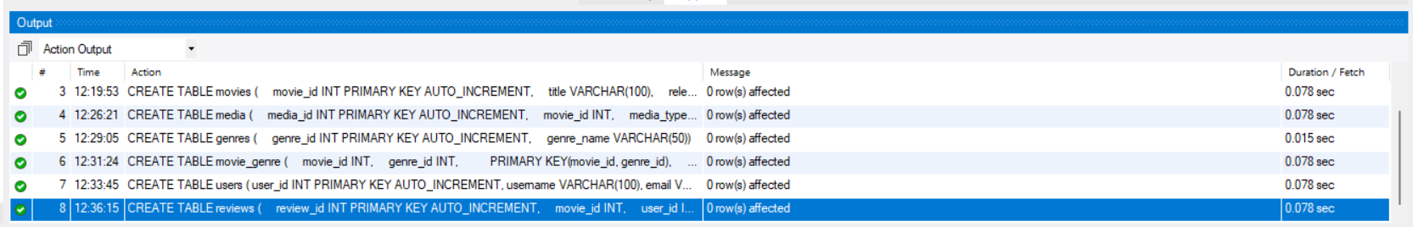

Step 9: Artists Table
Query: CREATE TABLE artists (
artist_id INT PRIMARY KEY AUTO_INCREMENT,
artist_name VARCHAR(100));

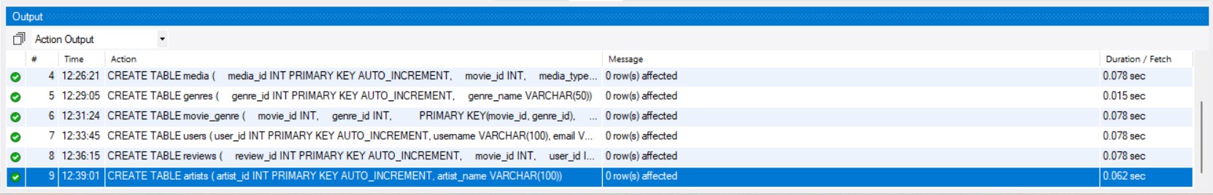

Step 10: Skills Table
Query: CREATE TABLE skills (
skill_id INT PRIMARY KEY AUTO_INCREMENT,
skill_name VARCHAR(50));

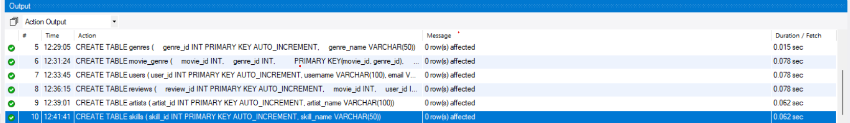

Step 11: Artist skill Table
Query: CREATE TABLE artist_skill (
artist_id INT,
skill_id INT,
PRIMARY KEY(artist_id, skill_id),
FOREIGN KEY(artist_id)
REFERENCES artists(artist_id),
FOREIGN KEY(skill_id)
REFERENCES skills(skill_id));

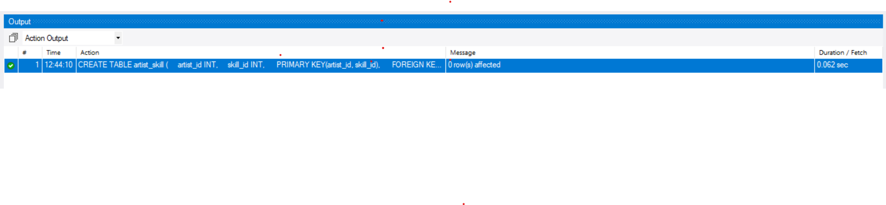
Step 12: Roles Table
Query: CREATE TABLE roles (
role_id INT PRIMARY KEY AUTO_INCREMENT,
role_name VARCHAR(50));

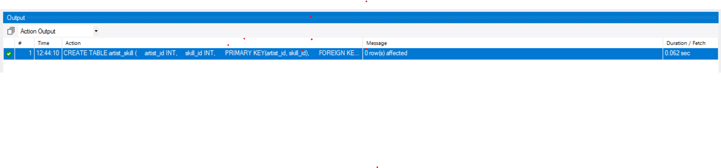
Step 13: Movie_Artist_Role table created
Query: CREATE TABLE movie_artist_role (
movie_id INT,
artist_id INT,
role_id INT,
PRIMARY KEY(movie_id, artist_id, role_id),
FOREIGN KEY(movie_id)
REFERENCES movies(movie_id),
FOREIGN KEY(artist_id)
REFERENCES artists(artist_id),
FOREIGN KEY(role_id)
REFERENCES roles(role_id));
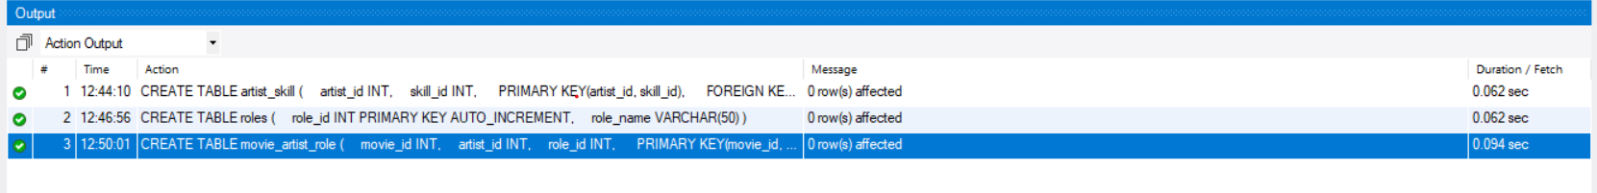

Step 14 : INSERTING VALUES INTO EACH TABLE
INSERTING VALUES FOR MOVIES TABLE :

QUERY : INSERT INTO movies(title, release_year, language)
VALUES
('Leo', 2023, 'Tamil'),
('Interstellar', 2014, 'English');

Step 15: INSERTING VALUES INTO EACH TABLE
INSERTING VALUES FOR MEDIA TABLE:

QUERY: INSERT INTO media(movie_id, media_type, media_url)
VALUES
(1, 'Image', 'leo_poster.jpg'),
(1, 'Video', 'leo_trailer.mp4'),
(2, 'Video', 'interstellar_trailer.mp4');

Step 16: INSERTING VALUES INTO EACH TABLE
INSERTING VALUES FOR GENRE TABLE:
Query: INSERT INTO genres(genre_name)
VALUES
('Action'),
('Thriller'),
('Sci-Fi'),
('Drama');
Step 17: INSERTING VALUES INTO EACH TABLE
INSERTING VALUES FOR movie_genre TABLE:

Query : INSERT INTO movie_genre(movie_id, genre_id)
VALUES
(1,1),
(1,2),
(2,3),
(2,4);

Step 18: INSERTING VALUES INTO EACH TABLE
INSERTING VALUES FOR USERS TABLE:

Query: INSERT INTO users(username, email)
VALUES
('Ravi', 'ravi@gmail.com'),
('Priya', 'priya@gmail.com');

Step 19: INSERTING VALUES INTO EACH TABLE
INSERTING VALUES FOR Reviews TABLE:
Query: INSERT INTO reviews(movie_id, user_id, rating, comment)
VALUES
(1,1,4.5,'Excellent movie'),
(1,2,4.0,'Very good action scenes');

Step 20 : INSERTING VALUES INTO EACH TABLE
INSERT INTO artists(artist_name)
VALUES
('Vijay'),
('Kamal Hassan');

Step 21 : INSERTING VALUES INTO EACH TABLE
INSERTING VALUES FOR SKILL NAME TABLE

Query : INSERT INTO skills(skill_name)
VALUES
('Acting'),
('Singing'),
('Dancing');

Step 22: INSERTING VALUES INTO EACH TABLE
INSERTING VALUES FOR ARTIST_SKILL TABLE:

Query : INSERT INTO artist_skill(artist_id, skill_id)
VALUES
(1,1),
(1,2),
(1,3);

Step 23: INSERTING VALUES INTO EACH TABLE
INSERTING VALUES FOR ROLES TABLE:

Query : INSERT INTO roles(role_name)
VALUES
('Actor'),
('Producer'),
('Writer');

Step 24 : INSERTING VALUES INTO EACH TABLE
INSERTING VALUES FOR MOVIE_ARTIST_ROLE :

Query : INSERT INTO movie_artist_role(movie_id, artist_id, role_id)
VALUES
(1,1,1),
(1,2,2),
(1,2,3);

Step 25: Showing all tables
Query : SHOW TABLES;
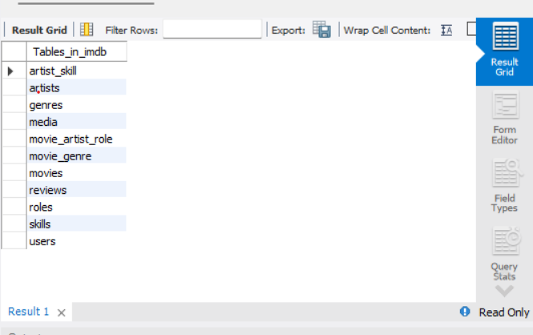

Step 26: Displaying all movies
Query: SELECT * FROM movies;

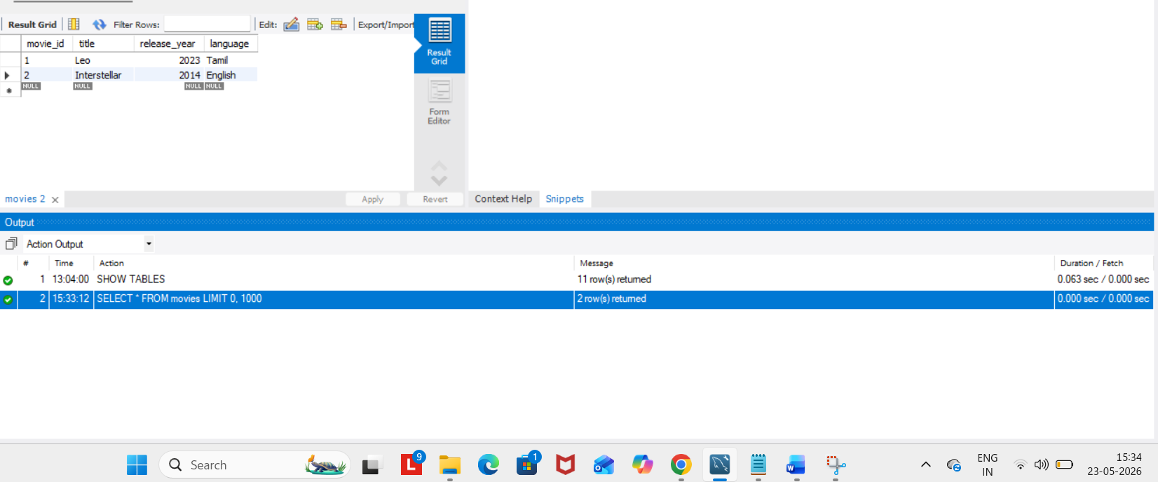

Step 27: See movie with genres
Query: SELECT m.title, g.genre_name
FROM movies m
JOIN movie_genre mg
ON m.movie_id = mg.movie_id
JOIN genres g
ON mg.genre_id = g.genre_id;

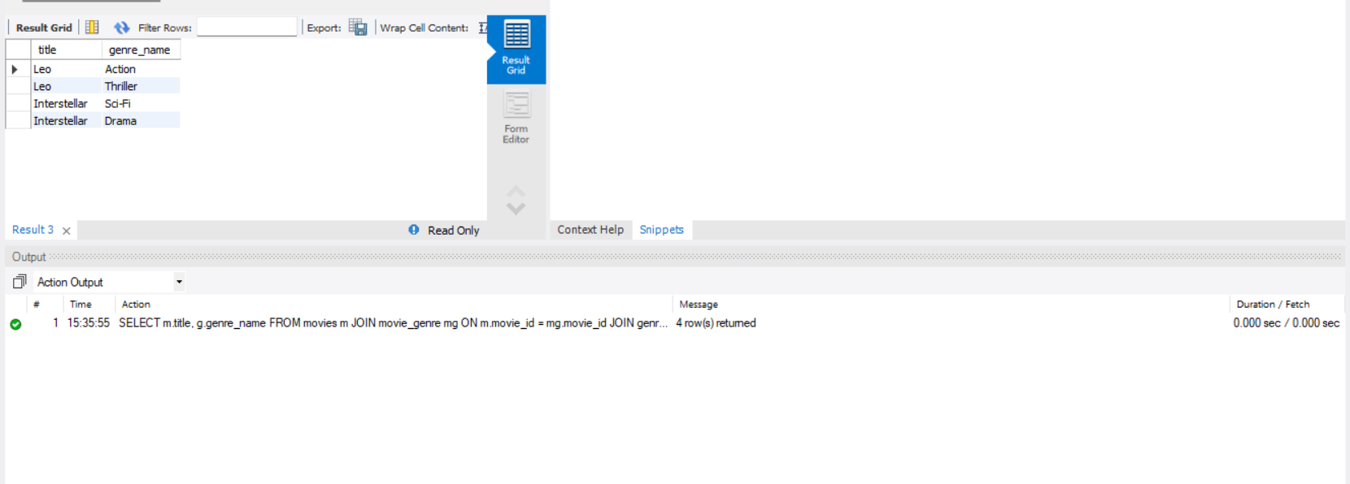

Step 28: See reviews
Query: SELECT u.username, m.title, r.rating, r.comment
FROM reviews r
JOIN users u
ON r.user_id = u.user_id
JOIN movies m
ON r.movie_id = m.movie_id;

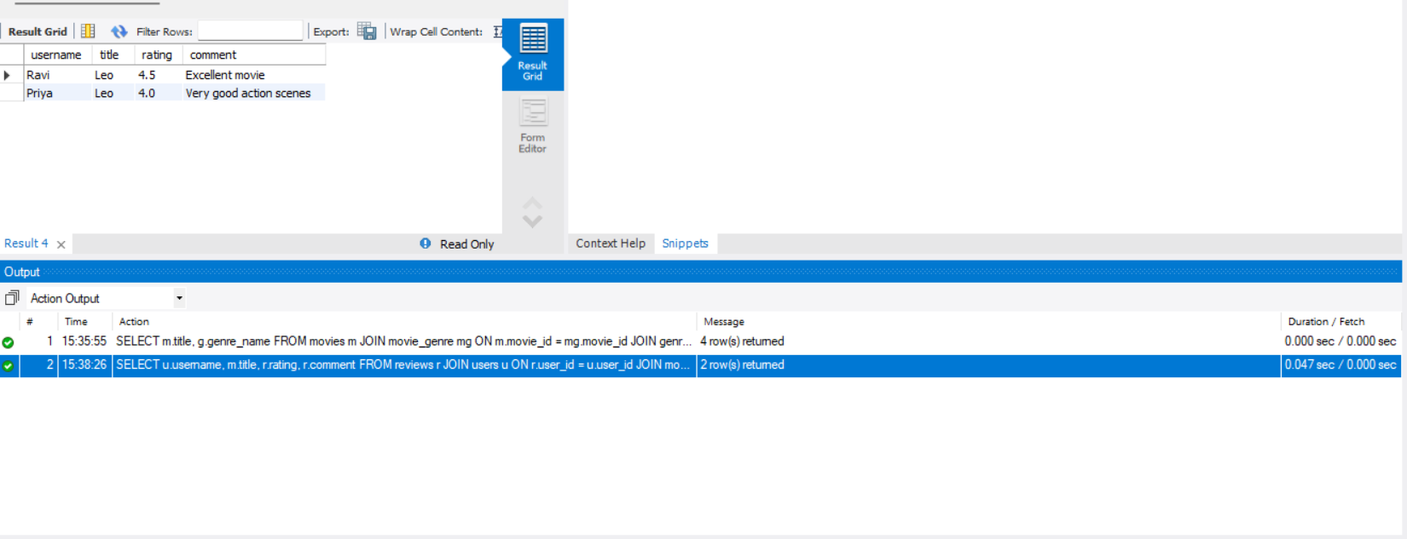

See artist skills
Query: SELECT a.artist_name, s.skill_name
FROM artist_skill ast
JOIN artists a
ON ast.artist_id = a.artist_id
JOIN skills s
ON ast.skill_id = s.skill_id;
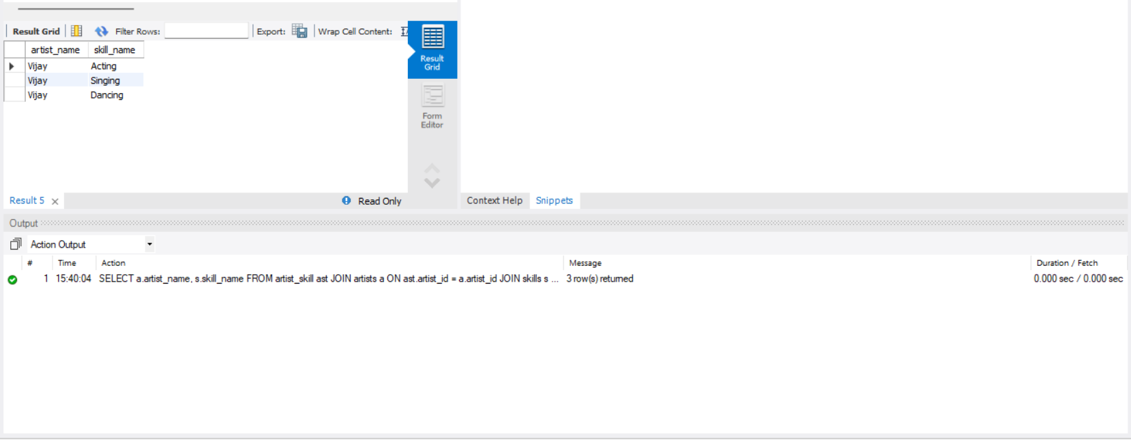

Artists perfrom multiple roles in a single film
Query: SELECT m.title, a.artist_name, r.role_name
FROM movie_artist_role mar
JOIN movies m
ON mar.movie_id = m.movie_id
JOIN artists a
ON mar.artist_id = a.artist_id
JOIN roles r
ON mar.role_id = r.role_id;

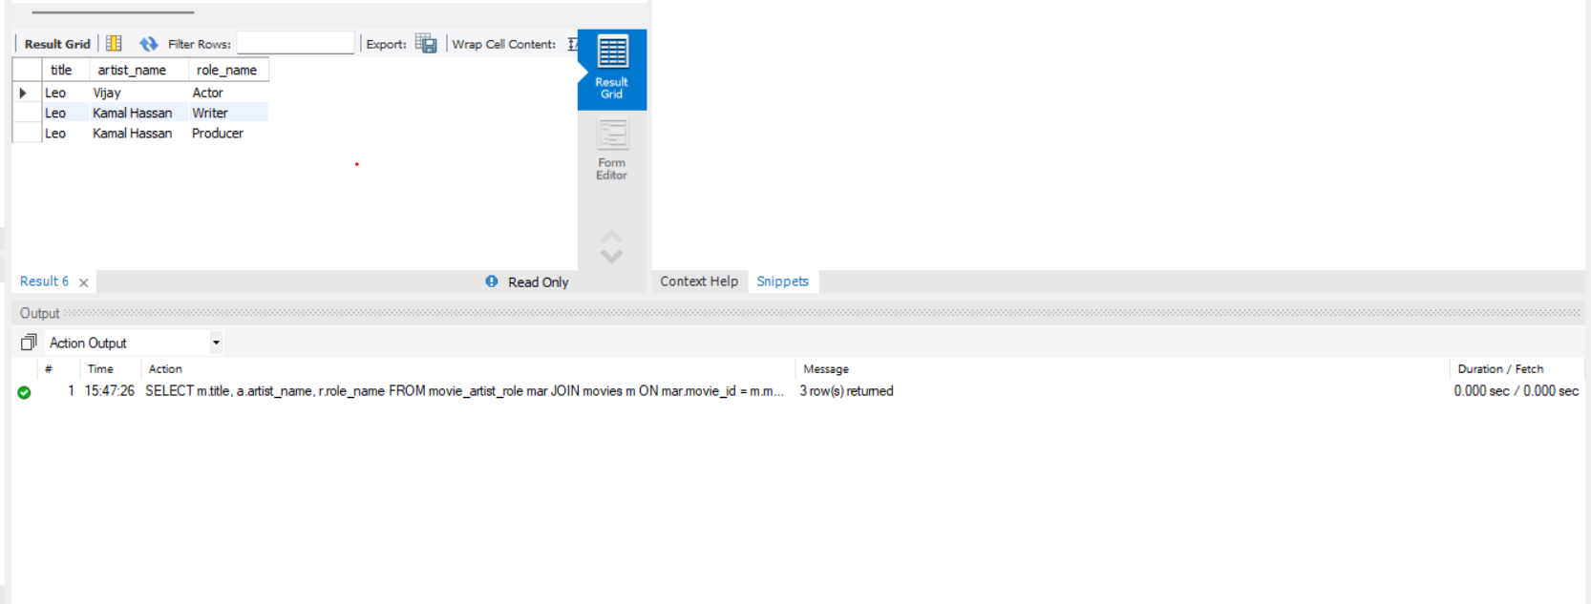

Conclusion:
Designed an IMDB database using MySQL with Primary Keys, Foreign Keys, One-to-Many and Many-to-Many relationships. Inserted sample data and executed JOIN queries.

